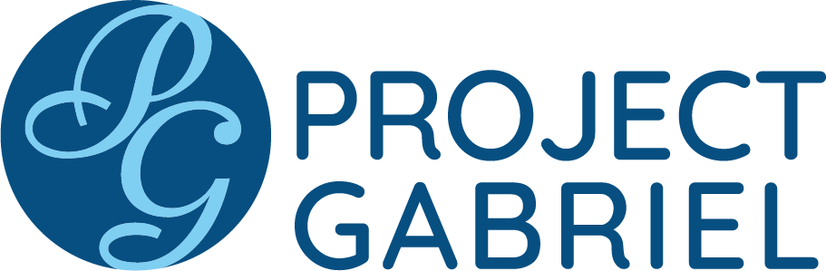
Gabriel’s Trumpet for Sunday Bulletins
November 8 – December 6, 2020
Catholic Pro-Life Community

For use on 11/08/20 For use on 11/29/20
Gabriel’s Trumpet
“Before I formed you in the womb I knew you; before you were born I dedicated you.” - Jeremiah 1:5

“When I discovered I was pregnant I felt so unprepared and really scared. Project Gabriel was my lifeline! I learned what was happening to my body, how God was preparing me to nurture and care for this tiny new person! The more I learned, the more confident I felt.”
- Mother assisted by Project Gabriel

Want to learn more about the practical, emotional and spiritual resources available to mothers in need?
Visit www.projectgabrieldallas.org.
or call 469-602-HELP

Gabriel’s Trumpet
“So it is not the will of my Father who is in heaven that one of these little ones should perish.” – Matthew 18:14

“If it had not been for my Gabriel Angel, my baby and I would have been living on the street.”
- Mother assisted by Project Gabriel

Want to learn more about the practical, emotional
and spiritual resources available to mothers in need
through Project Gabriel?
Visit www.projectgabrieldallas.org
or call 469-602-HELP

For use on 11/15/20 For use on 12/6/20
Gabriel’s Trumpet
“Come to me, all who labor and are heavy laden, and I will give you rest.” - Matthew 11:28-30
“May God bless all of you for the beautiful work you do. It’s a great relief to be able to count on you.”
- Mother assisted by Project Gabriel

Want to learn more about the practical, emotional and spiritual resources available to mothers in need?
Visit www.projectgabrieldallas.org
or call 469-602-HELP

Gabriel’s Trumpet
“Jesus said, ‘Suffer the little children, and do not forbid them to come unto me: for of such as these is the kingdom of heaven.’ And he laid his hands on them, and blessed them.” – Matthew 19:14-15.

“I like that in our classes we talk about how God loves little children. I try to take my son to church more often now.”
- Mother assisted by Project Gabriel
Want to learn more about the practical, emotional
and spiritual resources available to mothers in need
through Project Gabriel?
Visit www.projectgabrieldallas.org
or call 469-602-HELP

For use on 11/22/20
DIRECTIONS: Please insert the text box in the Sunday bulletin. Copy and paste the text box, clicking on the entire box and placing cursor on the frame of the box to copy. Please use the quote which corresponds with the correct Sunday’s date.

Gabriel’s Trumpet
“My frame was not hidden from you when I was made in secret .... Your eyes saw my unformed substance”.
- Psalm 139:15-16
“People were telling me that what I had inside me was just tissue and a baby isn’t really a person until it’s born. But I learned to value myself as a mother even before my baby came.” - Mother assisted by Project Gabriel
Want to learn more about the practical, emotional
and spiritual resources available to mothers in need
through Project Gabriel?
Visit www.projectgabrieldallas.org
or call 469-602-HELP

