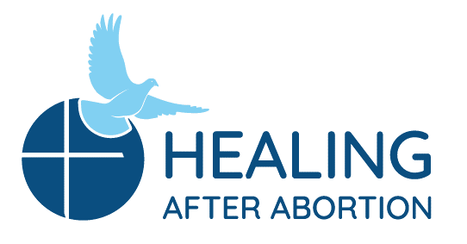
Rachel and Joseph Corner Quotes
for Sunday Bulletins
February 14, 2021 – March 24, 2021
Catholic Pro-Life Community
For use on 02/14/21

For use on 03/07/21
Joseph’s Corner
“Grieving your abortion losses is one of the most important tasks you will do in your lifetime. It starts as you stop denying your pain, and it continues until you reach a point of reconciliation.”
- A Season to Heal by Luci Freed & Penny Yvonne Salazar

Have you been denying what you really feel about your involvement in an abortion decision, trying to be strong for everyone else, yet feeling like you are falling apart inside? Join the men on their annual Project Joseph© Retreat. We have been there too.

Healing after Abortion Ministry – Project Joseph©
469-720-CARE (2273) • healing@projectjosephdallas.org
www.projectjosephdallas.org

Joseph’s Corner
“He pulled me up from the seething chasm, from the mud of the mire. He set my feet on rock and made my footsteps firm.” - Psalm 40:2

Before your involvement in an abortion decision, you may not have known how you would feel afterwards. Maybe you thought she would be the only one. Join the men on their annual Project Joseph© Retreat and discover how you can get your feet back on solid ground and be free from any burden you still carry since that day.

Healing after Abortion Ministry – Project Joseph©
469-720-CARE (2273) • healing@projectjosephdallas.org
www.projectjosephdallas.org

For use on 03/14/21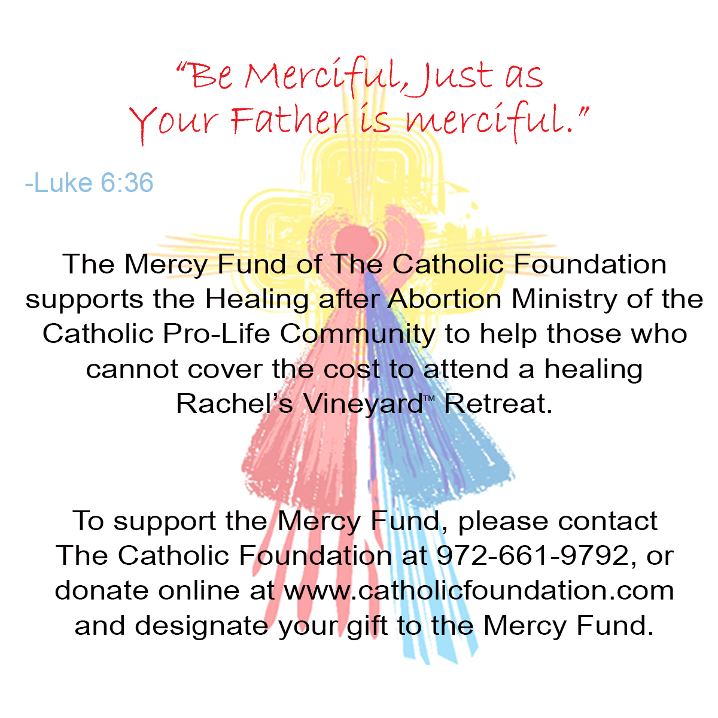9/19
FFor use on 02/21/21

For use on 06/21/20

Rachel’s Corner
“Hope in Me, and you will be protected from depression and self-pity. Hope is like a golden cord connecting you to heaven. The more you cling to this cord, the more I bear the weight of your burdens; thus, you are lightened. Heaviness is not of My kingdom. Cling to hope, and My rays of light will reach you through the darkness.
-Jesus Calling/by Sarah Young

Come on a Rachel’s Vineyard™ Retreat and re-discover what it feels like to have hope in your life again as you encounter His mercy.

Healing after Abortion Ministry
214-544-CARE (2273) • healing@racheldallas.org
www.racheldallas.org

For use on 02/28/21
DIRECTIONS: Please insert the text box in the Sunday bulletin. Copy and paste the text box, clicking on the entire box and placing cursor on the frame of the box to copy. Please use the quote which corresponds with the correct Sunday’s date. To copy the Mercy Corner, right click to copy, paste into bulletin.

Rachel’s Corner
I feel clean, and with a desire to keep going forward. I feel like a woman who after so very much time, God extended His hand to me and picked me up. I am loved just as I am by Jesus, and now feel worthy in the eyes of God. Thank you, God, for filling me with peace inside and for having received my daughter with so much love, forgiving me and for teaching me to forgive others. -Testimonial

A Rachel’s Vineyard™ Retreat can radically change how you feel about yourself and others. Join us on a retreat and see what it is like to feel peace again, as you are reminded of how much He loves you.
Healing after Abortion Ministry
214-544-CARE (2273) • healing@racheldallas.org
www.racheldallas.org

