April 14 – May 19, 2019
Rachel and Joseph Corner Quotes for Sunday Bulletins
For use on 4/21/19
Rachel’s Corner

“All grace flows from mercy, …. Let no one doubt concerning the goodness of God; even if a person’s sins were as dark as night, God’s mercy is stronger than our misery. One thing alone is necessary; that the sinner set ajar the door of his heart, be it ever so little, to let in a ray of God’s merciful grace, and then God will do the rest.”
- No. 1507 / Diary of Saint Faustina

Are you ready to open the door of your heart just enough to invite God in so He can show you how His mercy is stronger than your post-abortive pain? Join us on a Rachel’s Vineyard™ Retreat and come alive again as you are warmed by the rays of His healing mercy.
Healing after Abortion Ministry
214-544-CARE • healing@racheldallas.org
www.racheldallas.org

Joseph’s Corner
“Your courage will be rewarded. Everything is confidential and healing. You have nothing to lose and everything to gain.” -Testimonial

Do you ever wonder what it used to be like to not remember and feel that decision that led to abortion? Did you ever think you would also carry the pain and regret of that loss? We don’t think it will affect us and it does. Join the men of Project Joseph© for a Day of Healing, and re-discover that part of you that you thought was gone forever.

Healing after Abortion Ministry – Project Joseph©
469-416-2101 • healing@projectjosephdallas.org
www.projectjosephdallas.org

For use on 5/12/19
Rachel’s Corner
“You can’t press towards what lies ahead if you are dragging yesterday behind you.” -Joyce Meyer
It can be a very heavy burden to carry when you have post-abortive pain, shame and regret in your heart. How many years have you been carrying the burden of yesterday into your life today? God wants to help you cut those chains you are dragging and show you how your future filled with His merciful love can be so very different. Give yourself the chance. He is ready. Are you? Come on a Rachel’s Vineyard™ Retreat and discover that freedom there.
Healing after Abortion Ministry
214-544-CARE • healing@racheldallas.org
www.racheldallas.org

Joseph’s Corner

“I am empty of all pain. I can begin to forgive myself. We need to let our children rest in peace. I can go to communion now!! I went to confession!! I felt loved by my children! I am not alone anymore.” -Testimonial

Have you been feeling that guilt inside and wondering how you could ever forgive yourself for having participated in a decision that led to the abortion of your child? Did you think you had no right to heal? God wants to show you how He has been calling you to Him so you can let all that go. Come on a Project Joseph© Day of Healing for men and release that burden with a group of men who have been there too.
Healing after Abortion Ministry – Project Joseph©
469-416-2101 • healing@projectjosephdallas.org
www.projectjosephdallas.org

For use on 4/28/19
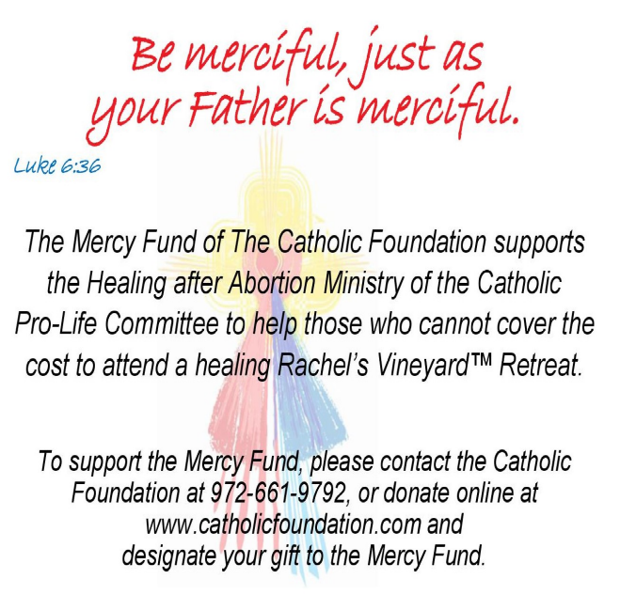
For use on 5/5/19
DIRECTIONS: Please insert the text box in the Sunday bulletin. Copy and paste the text box, clicking on the entire box and placing cursor on the frame of the box to copy. Please use the quote which corresponds with the correct Sunday’s date. To copy the Mercy Corner, right click to copy, past into bulletin.

For use on 5/19/19

