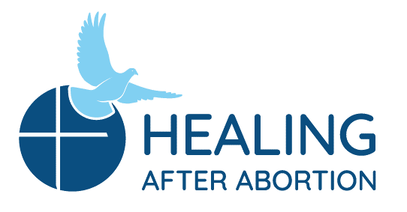
Rachel and Joseph Corner Quotes
for Sunday Bulletins
July 14 – August 11, 2019
Catholic Pro-Life Community
Joseph’s Corner
“It helped me understand the “why” of many feelings regarding the abortion and confirmed that God never abandoned me.” - Testimonial

Did you feel a sense of failure for not having found another solution to the problem, and then felt regret that consumed you as you remained silent? Join the men of Project Joseph© on their annual Day of Healing. Let God help you understand things you need to know – like how much God loves you, never abandoned you, and how He wants to help you be free of that burden you are carrying.

Healing after Abortion Ministry – Project Joseph©
469-416-2101 • healing@projectjosephdallas.org
www.projectjosephdallas.org

Rachel’s Corner

“Find God in all things.”
- St. Ignatius of Loyola- Feast day July 31
Yes, in the pain, shame and regret following your loss due to an abortion decision, you can find God as well. He wants nothing more than to hold you in His merciful arms and remind you that He has never stopped loving you and never will. Join us on a Rachel’s Vineyard™ Retreat and give Him that chance to do so.
Healing after Abortion Ministry
214-544-CARE • healing@racheldallas.org
www.racheldallas.org

For use on 7/28/19
Joseph’s Corner
“The best part was that I didn't even know I needed this healing, but God did! I felt His mercy and forgiveness at all moments.” - Testimonial

Have you been trying to be strong ever since the day you were involved in an abortion decision? Trying to convince yourself that you don’t need any help, and that there is nothing more to be done? God is calling you to something better – where you can be restored to who you were created to be once and always wanted to be. Join the men of Project Joseph© on their annual Day of Healing. You don’t have to be strong on your own anymore! Let the men of Project Joseph© tell you how they had to let that go and let God take the burden from them, so they could be the men God created them to be.

Healing after Abortion Ministry – Project Joseph©
469-416-2101 • healing@projectjosephdallas.org
www.projectjosephdallas.org

For use on 8/11/19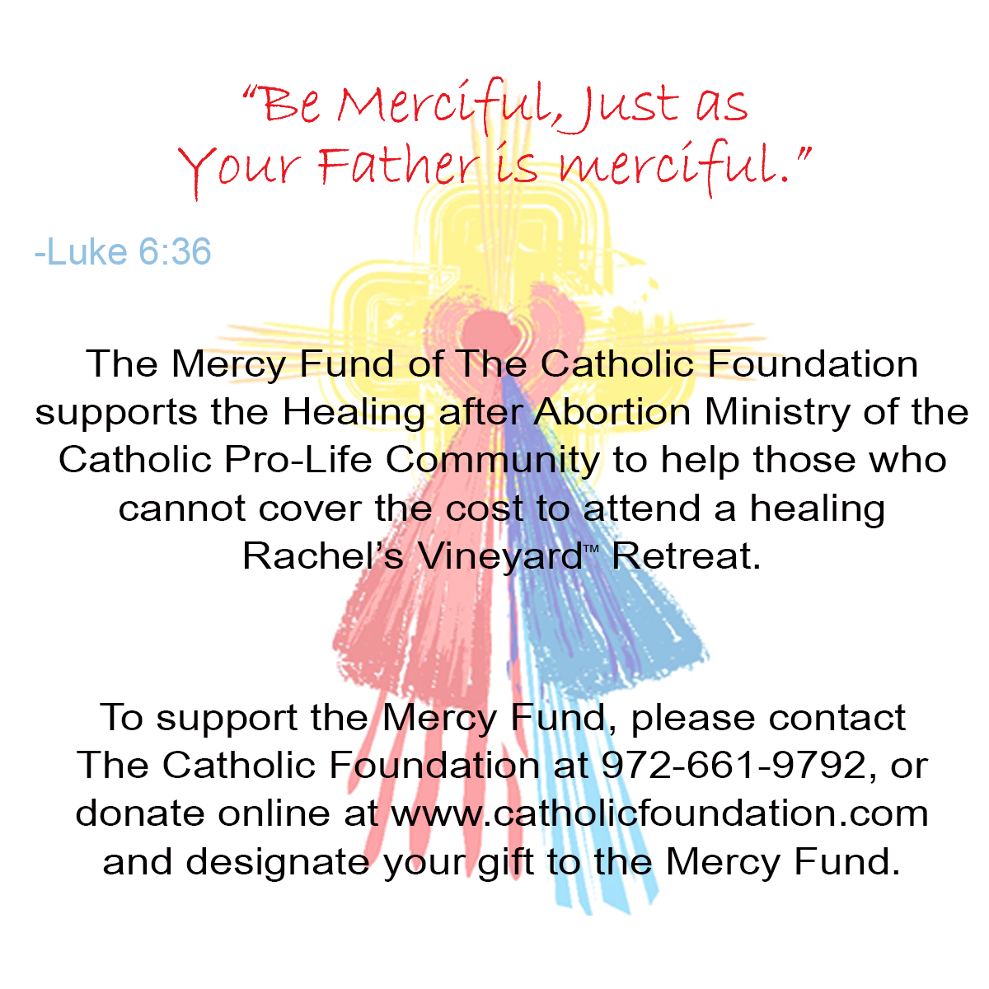9/19
For use on 7/21/19
Rachel’s Corner
“No matter how dark it gets, when you light a candle, the darkness can never overpower the light of Christ. We need to be a people of hope and recognize that God’s love in that light overpowers our darkness.”
- Fr. Larry Richards

Is it hard to imagine escaping the darkness you have known since your abortion decision? Would you be willing to invite God in, so He can show you the way with His light? Join us for a Rachel’s Vineyard™ Retreat.
Healing after Abortion Ministry
214-544-CARE • healing@racheldallas.org
www.racheldallas.org

For use on 7/14/19
For use on 8/4/19
DIRECTIONS: Please insert the text box in the Sunday bulletin. Copy and paste the text box, clicking on the entire box and placing cursor on the frame of the box to copy. Please use the quote which corresponds with the correct Sunday’s date. To copy the Mercy Corner, right click to copy, past into bulletin.

