March 17, 2019 - April 14, 2019
Rachel and Joseph Corner Quotes for Sunday Bulletins
For use on 3/17/19
Joseph’s Corner
“I feel liberated from the secret, the pain and the shame. I have also finally been able to connect with the children I lost to the abortions. They have realness now and I can carry them with me in a special way in my everyday life.”
- Testimonial
Are you tired of carrying the secret of your past abortion involvement, which seems to continuously judge and condemn you? Join the men on a Project Joseph© Day of Healing and see what life can be like once you are set free from that burden.
Healing after Abortion Ministry – Project Joseph©
469-416-2101 • healing@projectjosephdallas.org
www.projectjosephdallas.org

Rachel’s Corner
“In the beginning I felt guilt and the burden that would not let me breathe nor be at peace. Then I began to experience the mercy and healing from God and now I feel that I have been set free from what had me tied down. It was an experience of healing.” - Testimonial
Perhaps you too know what that burden feels like that seems to be relentless in filling your thoughts with guilt and self-condemnation, which don’t let you breathe and be at peace. Come on a Rachel’s Vineyard™ retreat and let us walk with you as you lay that burden down and allow God to show you how much He loves you and yearns for you to receive His merciful healing.
Healing after Abortion Ministry
214-544-CARE • healing@racheldallas.org
www.racheldallas.org
www.projectjosephdallas.org

For use on 4/7/19
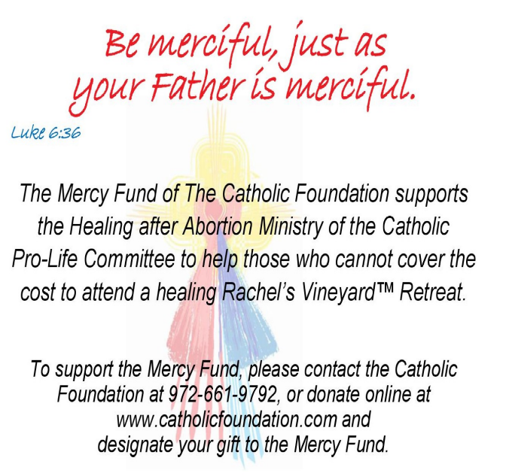
Joseph’s Corner
“I gave all to Our Lord, and He broke the chains, and I am free now. I feel more at peace and a deep feeling of joy and hope that I can one day be with my child, my God and with Jesus. That is the hope I had one day lost and now have again. I want to live in peace with my wife now and have a strong relationship with God.”
- Testimonial

Have you lost hope that you could ever be free of the chains that have imprisoned you since your participation in an abortion decision? Join the men on a Project Joseph© Day of Healing and hand those chains to Him. Be free again.
.Healing after Abortion Ministry – Project Joseph©
469-416-2101 • healing@projectjosephdallas.org
www.projectjosephdallas.org

For use on 3/31/19
Joseph’s Corner
"The Lord manifests Himself to those who stop for some time in peace and humility of heart. If you look in murky and turbulent waters, you cannot see the reflection of your face. If you want to see the face of Christ, stop and collect your thoughts in silence, and close the door of your soul to the noise of external things."
- St. Anthony of Padua
Has your participation in an abortion decision left you with turbulent waters that you have tried to deny and hide for a long time? Join the men of Project Joseph© for their annual Day of Healing.
Healing after Abortion Ministry – Project Joseph©
469-416-2101 • healing@projectjosephdallas.org
www.projectjosephdallas.org

For use on 3/24/19
DIRECTIONS: Please insert the text box in the Sunday bulletin. Copy and paste the text box, clicking on the entire box and placing cursor on the frame of the box to copy. Please use the quote which corresponds with the correct Sunday’s date. To copy the Mercy Corner, right click to copy, past into bulletin.

For use on 4/14/19

