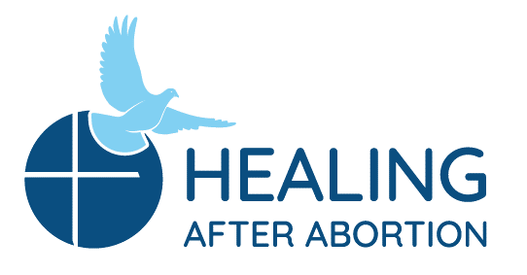
Rachel and Joseph Corner Quotes
for Sunday Bulletins
September 8 – October 13, 2019
Catholic Pro-Life Community

Rachel’s Corner

“We need no wings to go in search of Him but have only to look upon Him present within us.”

- St. Theresa of Jesus- Feast Day Oct 15
He was there that day when the abortion decision was made, and He is there with you now within you…only wanting you to know how much you are loved and how He wants to show you His merciful compassion. Will you give him that chance? Join us on a Rachel’s Vineyard™ Retreat.

Healing after Abortion Ministry
214-544-CARE • healing@racheldallas.org
www.racheldallas.org

Joseph’s Corner
“After having been to Project Joseph, I feel like I can forgive myself for my sin against my child.” -Testimonial
Is that something for which you yearn but at the same time can’t even imagine it happening? Do you feel like you can’t forgive yourself or be forgiven because of your involvement in an abortion decision? Join the men of Project Joseph© on a Day of Healing and find out what it is like to be free of that burden.
Healing after Abortion Ministry – Project Joseph©
469-605-7262 • healing@projectjosephdallas.org
www.projectjosephdallas.org
For use on 10/13/19
DIRECTIONS: Please insert the text box in the Sunday bulletin. Copy and paste the text box, clicking on the entire box and placing cursor on the frame of the box to copy. Please use the quote which corresponds with the correct Sunday’s date. To copy the Mercy Corner, right click to copy, past into bulletin.

Rachel’s Corner
“Healing can begin after we admit that we cannot fix ourselves. We need to say yes to our powerlessness and stop demanding miracles on our own terms. When we demand things of God, we keep running away from where we are and, in so doing, we do not allow ourselves to be held by the only One who can heal us.”
-Kathryn J. Hermes, FSP, “Surviving Depression”

Are you tired of running away from being held by the One who can heal you? It can be hard to admit we cannot do it on our own. That first step can mean everything. Allow people who have been there too and were able to yield to His merciful healing to walk with you on a Rachel’s Vineyard Retreat™. You won’t be sorry you gave it a try.

Healing after Abortion Ministry
214-544-CARE • healing@racheldallas.org
www.racheldallas.org

For use on 9/22/19
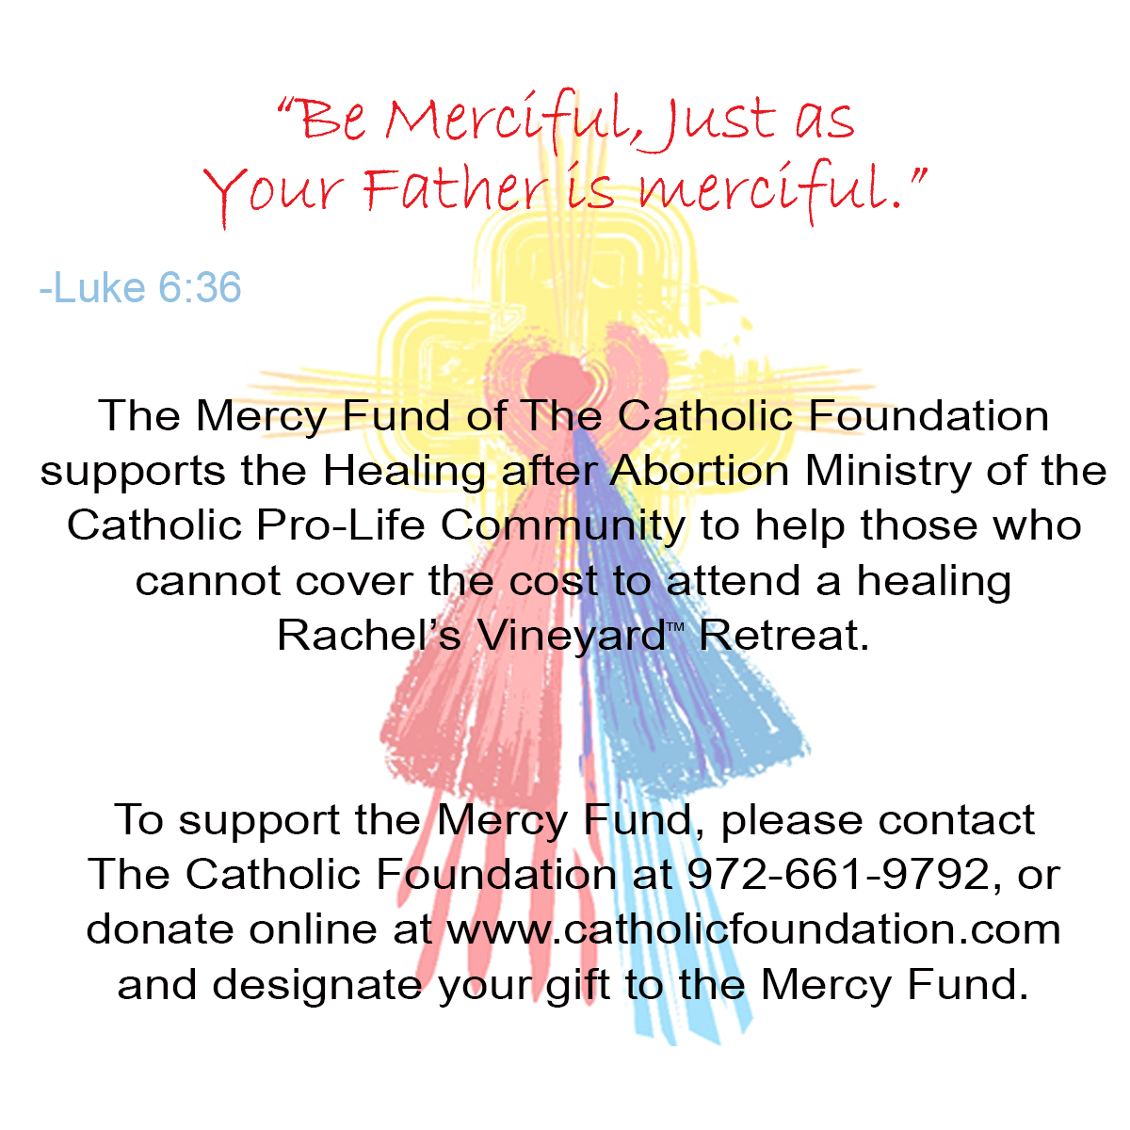
For use on 9/29/19
Joseph’s Corner
“I AM SO READY to NOT be a slave any longer and to be a CITIZEN OF LIFE!!” – Project Joseph Testimonial
How long has it been since your involvement in an abortion decision, where it may have left you feeling enslaved to regret, sadness, anger and so many other things, all held in silence within? Come on a Project Joseph© Day of Healing with men who have been there as well and have been able to leave that burden behind and become the men God has called them to be. Don’t miss this opportunity to feel alive again.
Healing after Abortion Ministry – Project Joseph©
469-605-7262 • healing@projectjosephdallas.org
www.projectjosephdallas.org

For use on 10/6/199/19
Rachel’s Corner
“I will give you a new heart, and a new spirit I will put within you. I will remove the heart of stone from your flesh and give you a heart of flesh” - Ezekiel 36:26

Did you feel like your heart turned to stone the day you made your abortion decision or maybe it felt that way over time? God can change that for you. Join us on a Rachel’s Vineyard™ Retreat and see what it feels like to receive His merciful love flooding your new heart of flesh. Will you accept His invitation?

Healing after Abortion Ministry
214-544-CARE • healing@racheldallas.org
www.racheldallas.org

For use on 9/15/19
For use on 9/8/19

