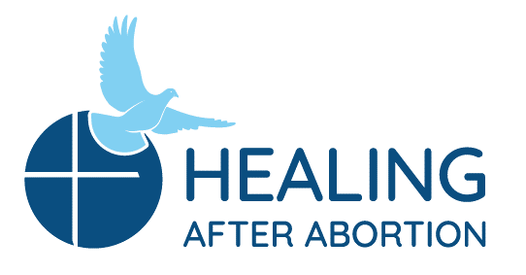
Rachel and Joseph Corner Quotes
for Sunday Bulletins
June 13, 2021 – July 11, 2021
Catholic Pro-Life Community
For use on 06/13/21

For use on 07/04/21
Rachel’s Corner
“Out of the depths I call to you, LORD; Lord, hear my cry! May your ears be attentive to my cry for mercy.”
- Psalm 130:1-2
Were those depths unknown until the day of your abortion decision? God knows those depths well and knows you are calling out to Him. Come on a Rachel’s Vineyard™ Retreat and let Him show you how He has heard you and has yearned to hold you in His merciful embrace.
Healing after Abortion Ministry
214-544-CARE (2273) • healing@racheldallas.org
www.racheldallas.org

Rachel’s Corner
“The pain of loss feels helpless because it comes from the past, and the past is a place where we have no power. We can’t do anything about the past, because it is already over. It no longer exists for us to control. Loss is very painful until we cross over. We must cross over for the past to the present, from what we had to what we have.”
- The Black Swan by Susan Anderson

Have you been suffering from that pain of loss since the day of the abortion decision? Join us on a Rachel’s Vineyard™ Retreat and invite healing into that wound.
Healing after Abortion Ministry
214-544-CARE (2273) • healing@racheldallas.org
www.racheldallas.org

For use on 06/21/20
FFor use on 06/20/21

For use on 07/11/21
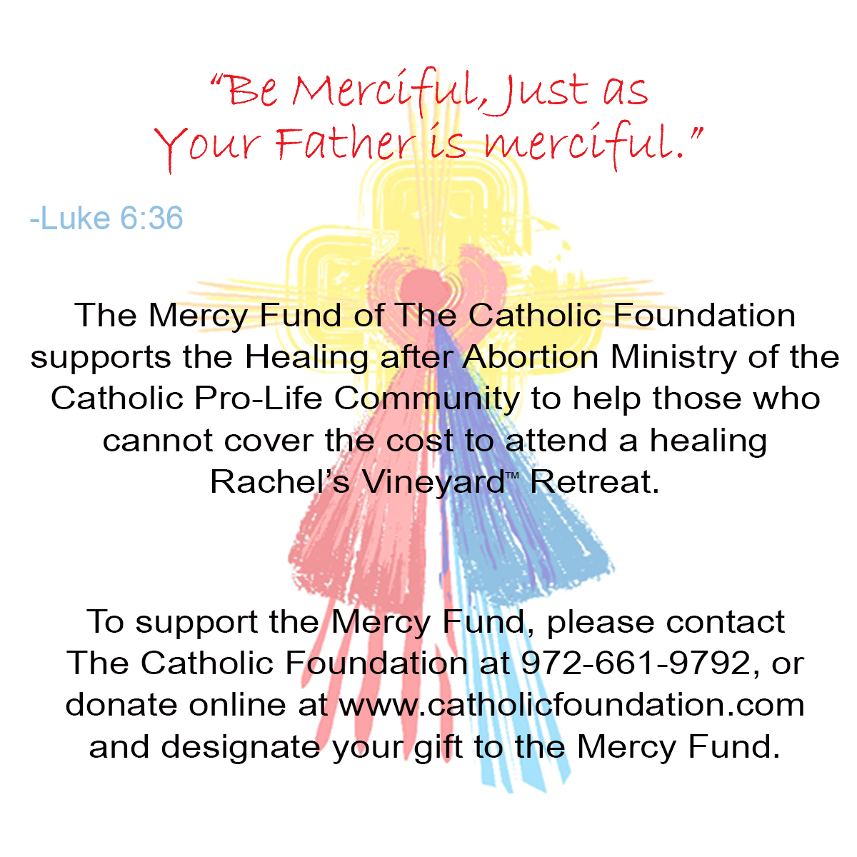9/19

Joseph’s Corner
“I feel closer to my wife than I have in a long time. I feel like I have had, through Project Joseph, the chance to see things from her perspective and discover grief and - emotions in myself that I didn't even know were there.”
- Testimonial

Locked doors in our hearts are opened on Project Joseph, and we discover that what we thought was hidden and untouchable, is what God can heal so we can be free again. Freedom to grieve our decision and loss, and freedom to come alive again.

Healing after Abortion Ministry – Project Joseph©
469-720-CARE (2273) • healing@projectjosephdallas.org
www.projectjosephdallas.org

For use on 06/27/21
Joseph’s Corner
“ I recognized my children as human beings and now I know that they are with Jesus. That is what has bothered me the most until now. Not knowing where they were. Thank you, Project Joseph!” - Testimonial

Are there painful questions you have held inside since your involvement in an abortion decision? Questions you have not shared with anyone? Join the men on Project Joseph© and find that they had those questions as well, and now are at peace.
Healing after Abortion Ministry – Project Joseph©
469-720-CARE (2273) • healing@projectjosephdallas.org
www.projectjosephdallas.org

DIRECTIONS: Please insert the text box in the Sunday bulletin. Copy and paste the text box, clicking on the entire box and placing cursor on the frame of the box to copy. Please use the quote which corresponds with the correct Sunday’s date. To copy the Mercy Corner, right click to copy, paste into bulletin.

