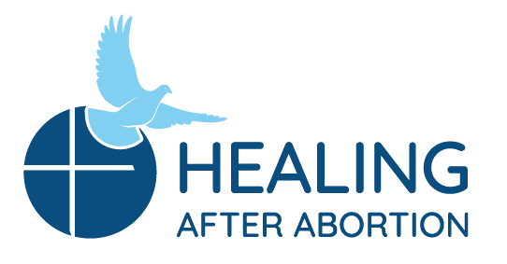
Rachel and Joseph Corner Quotes
for Sunday Bulletins
June 7, 2020 – July 12, 2020
Catholic Pro-Life Community
For use on 06/07/20
For use on 06/28/20
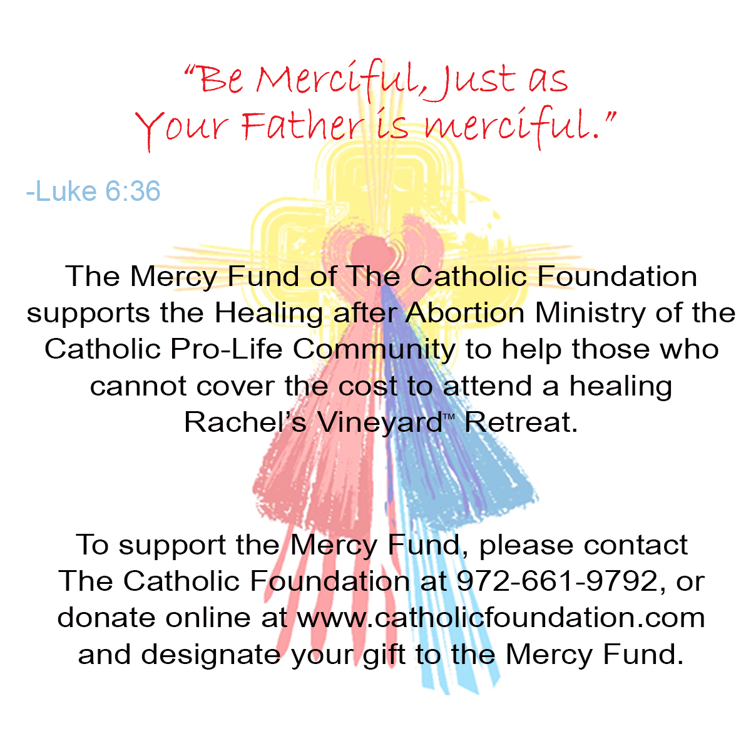
Joseph’s Corner
“Don’t be afraid to go into your pain. You can continue hiding, ignoring and silencing for more years, but it won't go away. There is light and hope for you ... for us. God forgives you and loves you and so does your child. Allow God to lead you and give yourself this time.” - Testimonial
It is time. Time to be free of what has been stored away since the abortion decision. To cease being something you always think about. Hurt about. Join the men of Project Joseph© for a Day of Healing and get to know the man you have always hoped to be.
Healing after Abortion Ministry – Project Joseph©
469-720-CARE (2273) • healing@projectjosephdallas.org
www.projectjosephdallas.org

For use on 06/14/20

DIRECTIONS: Please insert the text box in the Sunday bulletin. Copy and paste the text box, clicking on the entire box and placing cursor on the frame of the box to copy. Please use the quote which corresponds with the correct Sunday’s date. To copy the Mercy Corner, right click to copy, past into bulletin.

For use on 06/21/20
For use on 07/05/209/19

Rachel’s Corner
“He will wipe every tear from their eyes, and there shall be no more death or mourning, wailing or pain, [for] the old order has passed away. The one who sat on the throne said, ‘Behold, I make all things new’.”
- Revelation 21:4-5

Join us on a Rachel’s Vineyard Retreat™ and discover the peace of having Our Lord wipe away your tears from past abortion decisions and allow Him to make all things new in your heart again. It is His gift to you. Will you receive it?

Healing after Abortion Ministry
214-544-CARE (2273) • healing@racheldallas.org
www.racheldallas.org

Rachel’s Corner
“The light never goes out for us; it only hides behind the clouds of our present situation. The Holy One is just as present with us in our dark times as in our well-lighted ones.”
- Joyce Rupp, Little Pieces of Light

Did it feel like the light went out the day of your abortion decision and you were submerged in darkness? It can be comforting to know that the light is still there, and so is God. He wants nothing more than to embrace you on a Rachel’s Vineyard Retreat™ and remind you of His light as well as your own. Join us.
Healing after Abortion Ministry
214-544-CARE (2273) • healing@racheldallas.org
www.racheldallas.org

For use on 07/12/20
For use on 06/21/20
Joseph’s Corner
“This was a 20-year weight taken off me. My heart had become hard as a rock. Until today I had abandoned God completely. I will give Him now my lukewarmness and allow God to be God. Thank you, Project Joseph”.
- Testimonial

Join us on our annual Project Joseph© Day of Healing for men. We know what that hardened heart feels like as well as trying to make it without God. You don’t have to go on like that. Our lives changed, and so can yours.

Healing after Abortion Ministry – Project Joseph©
469-720-CARE (2273) • healing@projectjosephdallas.org
www.projectjosephdallas.org

Joseph’s Corner
"Until today I was dragging chains behind me as I climbed mountains. My guilt is what kept me from my children. Thanks to Project Joseph I am not dragging chains anymore and I can be the dad I have always wanted to be.” - Testimonial

Come on the annual Project Joseph© Day of Healing and be free of all that you have been dragging since your involvement in an abortion decision. We get it. We have been there. We are free of all that now, and the same can be for you. See you there.

Healing after Abortion Ministry – Project Joseph©
469-720-CARE (2273) • healing@projectjosephdallas.org
www.projectjosephdallas.org

