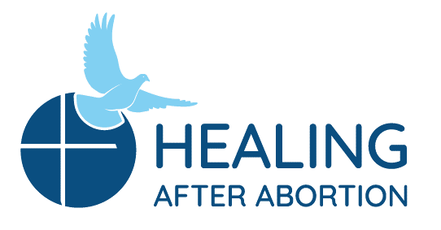
Rachel and Joseph Corner Quotes
for Sunday Bulletins
May 9, 2021 – June 13, 2021
Catholic Pro-Life Community
For use on 05/09/21

For use on 05/30/21
Rachel’s Corner
“The LORD will fight for you; you have only to keep still.”
- Exodus 14:14
Have you been trying everything to keep from thinking about the day when the abortion took place? Come on a Rachel’s Vineyard Retreat™ with us and find in the stillness of His embrace, how calming His mercy and peace can be. He is fighting for you! He wants you back!

Healing after Abortion Ministry
214-544-CARE (2273) • healing@racheldallas.org
www.racheldallas.org

Rachel’s Corner
“Hope has two beautiful daughters; their names are Anger and Courage. Anger at the way things are, and Courage to see that they do not remain as they are.”
- Saint Augustine- feast day May 27
Are you familiar with the anger felt inside since your abortion decision? Courage is there as well and is inviting you to join us on a Rachel’s Vineyard™ Retreat so you can re-discover hope again.

Healing after Abortion Ministry
214-544-CARE (2273) • healing@racheldallas.org
www.racheldallas.org

For use on 06/06/21
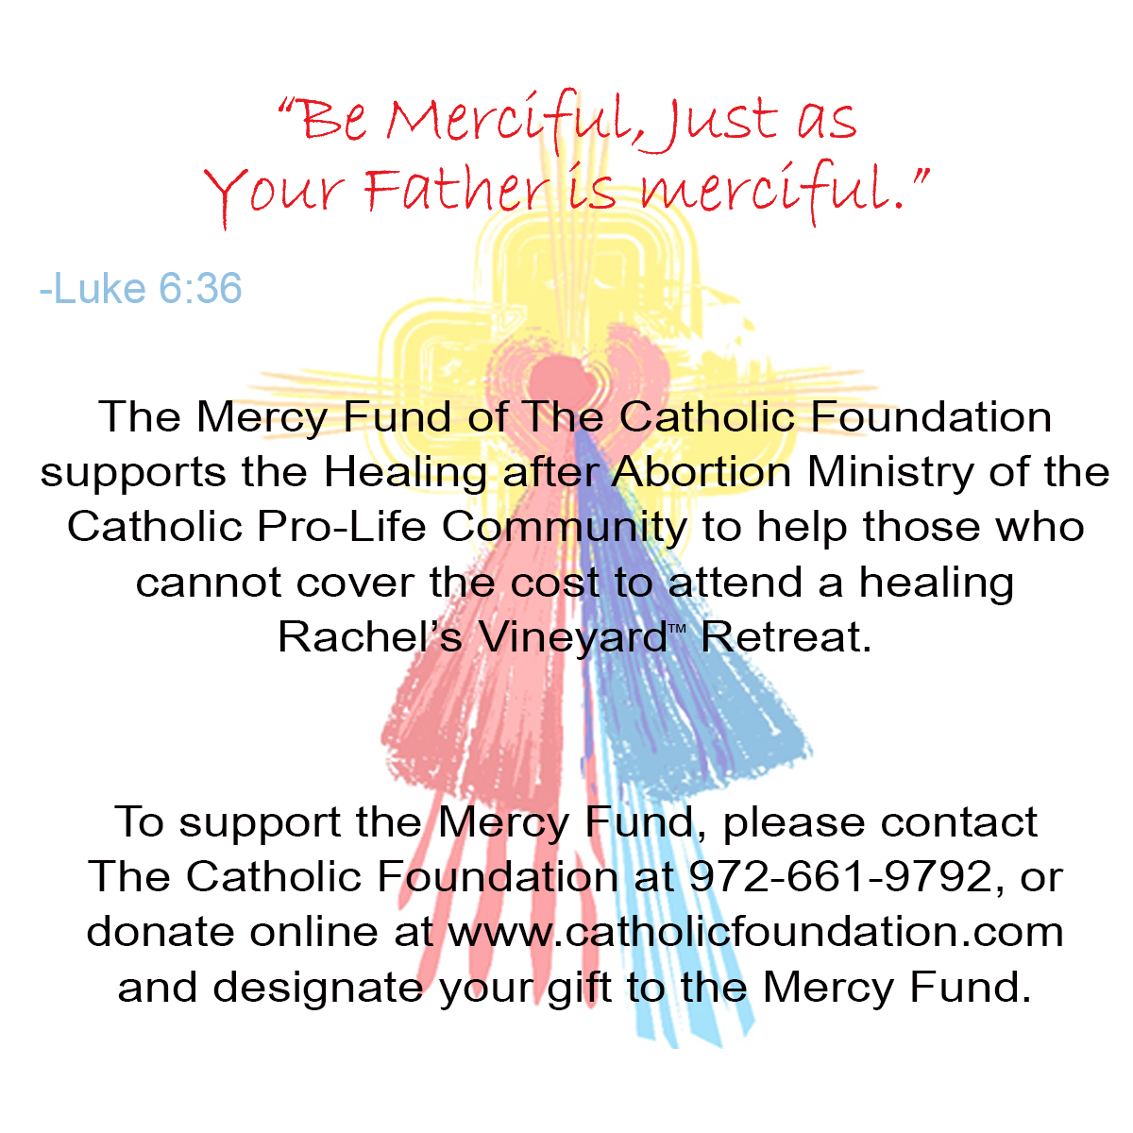9/19
FFor use on 05/16/21

For use on 06/21/20
Joseph’s Corner
“As a man this is something we don't talk about, even with our closest friends. For years I privately carried the guilt, shame and regret over the loss of my child. Attending the retreat allowed me to finally open up and share with others that have been down the same road. Through this I was able to open my heart to receiving God's forgiveness.”
- Testimonial

Once we find a safe place in which to release that burden we carry, we make room for the healing to begin. Join the men on their annual retreat.

Healing after Abortion Ministry – Project Joseph©
469-720-CARE (2273) • healing@projectjosephdallas.org
www.projectjosephdallas.org

For use on 05/23/21
For use on 06/13/21
Rachel’s Corner
“The pain of loss feels helpless because it comes from the past, and the past is a place where we have no power. We can’t do anything about the past, because it is already over. It no longer exists for us to control. Loss is very painful until we cross over. We must cross over for the past to the present, from what we had to what we have.” - The Black Swan by Susan Anderson

Have you been suffering from that pain of loss since the day of the abortion decision? Join us on a Rachel’s Vineyard™ Retreat and invite healing into that wound.
Healing after Abortion Ministry
214-544-CARE (2273) • healing@racheldallas.org
www.racheldallas.org

Joseph’s Corner
“I am a practicing Catholic and had been to confession. I knew that God had forgiven me, but I was never able to forgive myself. During the retreat I finally found the faith and courage that I needed to trust in Jesus and through His Divine Mercy truly know and believe in the forgiveness that I had been given.” - Testimonial
There is a difference between knowing you are forgiven and really accepting it fully. Join the men on their annual Project Joseph© Retreat and find out more about how that works.

Healing after Abortion Ministry – Project Joseph©
469-720-CARE (2273) • healing@projectjosephdallas.org
www.projectjosephdallas.org

DIRECTIONS: Please insert the text box in the Sunday bulletin. Copy and paste the text box, clicking on the entire box and placing cursor on the frame of the box to copy. Please use the quote which corresponds with the correct Sunday’s date. To copy the Mercy Corner, right click to copy, paste into bulletin.

