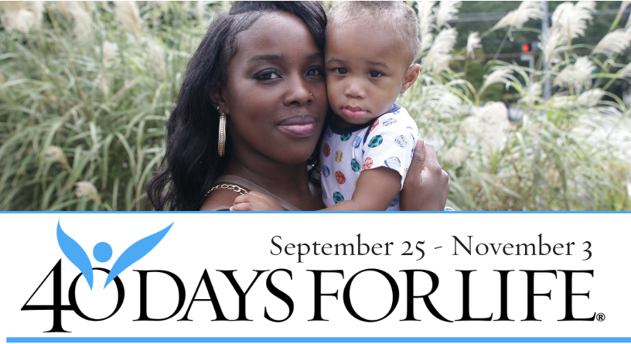

HELP SAVE LIVES IN DALLAS!

You can protect mothers and children by joining this worldwide mobilization to pray and fast for an end to abortion!
Through prayer and fasting, peaceful vigils and community outreach, 40 Days for Life has inspired 1,000,000 volunteers!
With God’s help, here are the proven results in 24 coordinated campaigns:
- 16,004 babies saved from abortion
- 190 abortion workers converted
- 100 abortion centers closed
Here’s how to take part in 40 Days for Life in our community:
- Vigil location: Southwestern abortion facility
8616 Greenville at Royal, Dallas
- Date / Time: [Insert date and time adopted by church / organization]
- Contact: [Insert church / organization contact name and phone / email]
- Learn more at: www.prolifedallas.org/40days

prolifedallas.org/40days

