Novena to Our Lady of America
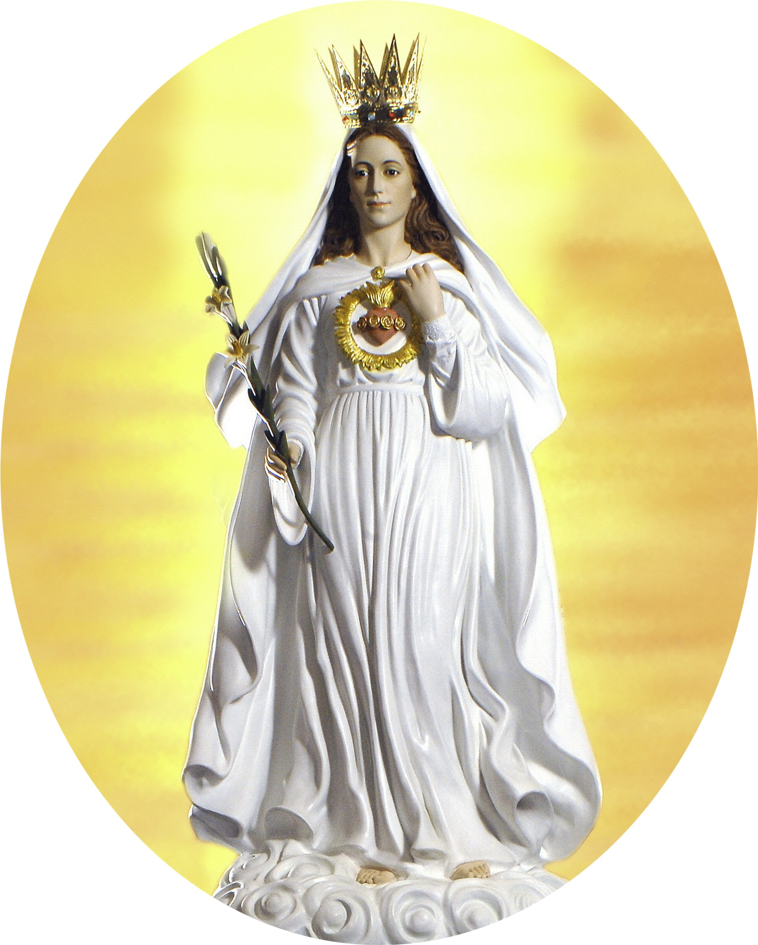
Our Lady of America is the only canonically approved devotion that is based upon apparitions of Our Lady in the United States. She said:

"I desire, through my children in America, to further the cause of faith and purity among peoples and nations. Let them come with confidence and simplicity, and I, their Mother, will teach them to become pure like to my Heart that their own hearts may be more pleasing to the Heart of my Son."
"I come to you, O children of America, as a last resort. I plead with you to listen to my voice. Cleanse your souls in the Precious Blood of My Son. Live in His Heart, and take me in that I may teach you to live in great purity of heart which is so pleasing to God. Be my army of chaste soldiers, ready to fight to the death to preserve the purity of your souls. I am the Immaculate One, Patroness of your land. Be my faithful children as I have been your faithful Mother."

Our Lady of America asked us for purity and promised us peace and protection. Let us lead pure lives and pray through her for peace and protection.

Please pray this novena on any nine consecutive days or continuously to Election Day, November 4, 2008, but most importantly during the nine consecutive days before Election Day beginning October 26.

Novena to Our Lady of America

After praying each day’s petition, pray the following:

Sister Mildred’s Prayer to Our Lady of America

O Immaculate Mother, Queen of our Country, open our hearts, our homes, and our Land to the coming of Jesus, your Divine Son. With Him, reign over us, O heavenly Lady, so pure and so bright with the radiance of God's light shining in and about you. Be our Leader against the powers of evil set upon wresting the world of souls, redeemed at such a great cost by the sufferings of your Son and of yourself, in union with Him, from that same Savior, Who loves us with infinite charity.

We gather about you, O chaste and holy Mother, Virgin Immaculate, Patroness of our beloved Land, determined to fight under your banner of holy purity against the wickedness that would make all the world an abyss of evil, without God and without your loving maternal care.

We consecrate our hearts, our homes, our Land to your Most Pure Heart, O great Queen, that the kingdom of your Son, our Redeemer and our God, may be firmly established in us. We ask no special sign of you, sweet Mother, for we believe in your great love for us, and we place in you our entire confidence. We promise to honor you by faith, love, and the purity of our lives according to your desire.

Reign over us, then, O Virgin Immaculate, with your Son Jesus Christ. May His Divine Heart and your most chaste Heart be ever enthroned and glorified among us. Use us, your children of America, as your instruments in bringing peace among men and nations. Work your miracles of grace in us, so that we may be a glory to the Blessed Trinity, Who created, redeemed, and sanctifies us.

May your valiant Spouse, St. Joseph, with the holy Angels and Saints, assist you and us in “renewing the face of the earth.” Then when our work is over, come, Holy Immaculate Mother, and as our Victorious Queen, lead us to the eternal kingdom, where your Son reigns forever as King. Amen.

Our Father... Hail Mary... Glory Be...

By thy holy and Immaculate Conception, O Mary, deliver us from evil!

Daily Novena Petitions and Schedule of Traveling Missionary Image
of Our Lady of America in Dallas

Day One, Sunday, October 26

The Missionary Image of Our Lady of America will be at Robinson’s abortion center, one of the two 40 Days for Life-Dallas vigil sites, 1921 Record Crossing, from 7:00 a.m. - 8:00 p.m. (vigil hours adopted by St. Elizabeth of Hungary Parish, Dallas)

Our Lady of America, you asked that the United States of America “be the country dedicated to my purity” and that your children in America “be the children of my Pure Heart.”

Please intercede for us that we may be granted this grace and a morally good president who will act according to the revealed will of God and the foundational principles of the Declaration of Independence and the Constitution of the United States of America.

Day Two, Monday, October 27

The Missionary Image of Our Lady of America will be at Planned Parenthood abortion center, one of the two 40 Days for Life-Dallas vigil sites, 7424 Greenville Avenue, during the 24-hour period from 12:00 a.m. - 11:59 p.m. (vigil hours adopted by St. Andrew Kim Parish, Dallas)

Our Lady of America, you said, “I desire, through my children of America, to further the cause of faith and purity among peoples and nations. Let them come to me with confidence and simplicity, and I, their Mother, will teach them to become pure like to my Heart that their own hearts may be more pleasing to the Heart of my Son.”

Please intercede for us that we may be granted this grace and a morally good president who will act according to the revealed will of God and the foundational principles of the Declaration of Independence and the Constitution of the United States of America.

Day Three, Tuesday, October 28

The Missionary Image of Our Lady of America will be at Planned Parenthood abortion center, one of the two 40 Days for Life-Dallas vigil sites, 7424 Greenville Avenue, during the 24-hour period of 12:00 a.m. - 11:59 p.m. (vigil hours adopted by St. Philip the Apostle Parish, Dallas)

Our Lady of America, you said, “What I ask, have asked, and will continue to ask is reformation of life. There must be sanctification from within. I will work my miracles of grace only in those who ask for them and empty their souls of the love and attachment to sin and all that is displeasing to my Son.”

Please intercede for us that we may be granted this grace and a morally good president who will act according to the revealed will of God and the foundational principles of the Declaration of Independence and the Constitution of the United States of America.

Day Four, Wednesday, October 29

The Missionary Image of Our Lady of America will be at Planned Parenthood abortion
center, one of the two 40 Days for Life-Dallas vigil sites, 7424 Greenville Avenue, from 12:00
a.m. - 7:30 a.m. (vigil hours adopted by All Saints Parish, Dallas); North Park abortion center, 8363 Meadow Road, Dallas (very close to Planned Parenthood), from 8:00 a.m. - 10:30 a.m.; and again at Planned Parenthood abortion center at 11:00 a.m.

Our Lady of America, you said, “My dear children, either you will do as I desire and reform your lives, or God Himself will need to cleanse you in the fires of untold punishment. You must be prepared to receive His great gift of peace.”

Please intercede for us that we may be granted this grace and a morally good president who will act according to the revealed will of God and the foundational principles of the Declaration of Independence and the Constitution of the United States of America.

Day Five, Thursday, October 30

The Missionary Image of Our Lady of America will be at Fairmount abortion center, 2921 Fairmount (at Cedar Springs), Dallas, from 8:00 a.m. - 1:00 p.m., and at Robinson’s abortion center, one of the two 40 Days for Life-Dallas vigil sites, 1921 Record Crossing, Dallas, from 1:30 p.m. - 11:59 p.m. (vigil hours adopted by Our Lady of Lebanon Parish, Lewisville)

Our Lady of America, you said, “It is the wish of my Son that fathers and mothers strive to imitate me and my chaste spouse in our holy life at Nazareth. We practiced the simple virtues of family life, Jesus our Son being the center of all our love and activity. The Holy Trinity dwelt with us in a manner far surpassing anything that can ever be imagined. For ours was the earthly paradise where once again God walked among men.”. . .

“The Divine Trinity will dwell in your midst only if you are faithful in practicing the virtues of our life at Nazareth. Then, you also, my children, you also will become another paradise. God will then walk among you and you will have peace.”

Please intercede for us that we may be granted this grace and a morally good president who will act according to the revealed will of God and the foundational principles of the Declaration of Independence and the Constitution of the United States of America.

Day Six, Friday, October 31

The Missionary Image of Our Lady of America will be at Robinson’s abortion center, one of the two 40 Days for Life-Dallas vigil sites, 1921 Record Crossing, from 12:00 a.m. - 6:00 p.m. (vigil hours adopted by Blessed Sacrament Parish, Dallas), and the Carmelite Monastery, 600 Flowers Avenue, Dallas 75211, located off of Jefferson Blvd, from 7:00 p.m. - 11:59 p.m. (during All-night Eucharistic Adoration in Prayer for the Elections)

Our Lady of America, you asked your beloved sons, the priests, “to practice self-denial and penance in a special manner, because it is you who must lead my children in the way of peace. . . Thus, by sanctification from within you, you will become a bright and burning light to the faithful, who look to you for help and guidance.”

Please intercede for us that we may be granted this grace and a morally good president who will act according to the revealed will of God and the foundational principles of the Declaration of Independence and the Constitution of the United States of America.

Day Seven, Saturday, November 1

The Missionary Image of Our Lady of America will be at the Carmelite Monastery, 600 Flowers Ave., Dallas 75211, located off of Jefferson Blvd, from 12:00 a.m. - 7:00 a.m. (during All-night Eucharistic Adoration in Prayer for the Elections), and at Planned Parenthood abortion center, one of the two 40 Days for Life-Dallas vigil sites, 7424 Greenville Avenue, from 8:00 a.m. - 11:59 p.m. (vigil hours adopted by Divine Mercy Parish, Mesquite)

Our Lady of America, you asked that the youth of our nation be the leaders of a movement of renewal on the face of the earth. You asked that they be prepared by instilling into them, not only the knowledge of the Divine Indwelling, but a serious study of it, living it in such a way that the Divine Presence becomes, as it were an intimate and necessary part of their life and daily living. From this will flow a great love, a conflagration that will envelop the world in the flames of Divine Charity.”

Please intercede for us that we may be granted this grace and a morally good president who will act according to the revealed will of God and the foundational principles of the Declaration of Independence and the Constitution of the United States of America.

Day Eight, Sunday, November 2

The Missionary Image of Our Lady of America will be at Robinson’s abortion center, one of the two 40 Days for Life-Dallas vigil sites, 1921 Record Crossing, during the 24-hour period from 12:00 a.m. - 11:59 p.m. (vigil hours adopted by St. Augustine Parish, Dallas). There will be a candlelight prayer service from 11:00 p.m. – 11:59 p.m. to conclude the 40 Days for Life-Dallas Prayer Vigils at both Robinson’s and Planned Parenthood abortion centers.

Our Lady of America, you said that those who wear your medal “with great faith and fervent devotion to you will receive the grace of intense purity of heart and the particular love of the Holy Virgin and her Divine Son.” You also said, “Sinners will receive the grace of repentance and the spiritual strength to live as true children of Mary. As in life, so in death, this blessed medal will be as a shield to protect them against the evil spirits, and St. Michael himself will be at their side to allay their fears at the final hour.”

Please intercede for us that we may be granted this grace and a morally good president who will act according to the revealed will of God and the foundational principles of the Declaration of Independence and the Constitution of the United States of America.

Day Nine, Monday, November 3

The Missionary Image of Our Lady of America will be at the Catholic Pro-Life Committee office, 14200 Midway Road, Suite 120, Dallas, from 8:00 a.m. until FedEx picks her up.

Our Lady of America, you asked that a statue be made in your image and placed, after being solemnly carried in procession, in the Basilica of the National Shrine of the Immaculate Conception in Washington, D.C. You said that you wished to be honored there in a special way as Our Lady of America, the Immaculate Virgin. You promised that the placement of your statue in the Shrine would be a special safeguard for our country.

Please intercede for us that we may be granted this grace and a morally good president who will
act according to the revealed will of God and the foundational principles of the Declaration of
Independence and the Constitution of the United States of America.

